Appendix – Scripts

No. 1 – Brāhmī derived scripts (Haarmann 1991: 521-523)
- Devanagari - Tamil
- Gurmukhi - Malayalam
- Gujarati - Kannada
- Bengali - Sinhalese
- Oriya

No. 2 – Georgian script (Haarmann 1991: 354)

No. 3 – Old Uyghur script (Kara 1996: 541)

No. 4 – Cuneiform writing (Haarmann 1991: 232)

No. 5 – Cyrillic alphabet (Haarmann 1991: 486)

No. 6 – Arabic alphabet (Kaye 1996: 747, 748, 754, 757, 758)
- for Farsi
- for Kurdish
- for Sindhi
- for Urdu
- for Turkish

No. 7 – Hurrian Cuneiform (Gragg 1996: 63)

No. 8 – Lycian alphabet (Swiggers & Jennings 1996: 283)

No. 9 – Aramaic alphabet (Jensen 1970: 301)

No. 10 – Pollard system (Zhou 2003: 316-321)
- original Pollard script
- reformed Pollard script (Roman)
- Pinyin-oriented Pollard script
- Reformed original Pollard script

No. 11 – Sequoyah script (Jensen 1970: 242)

No. 12 – Inuktitut writing (Nichols 1996: 607)

No. 13 – Abur alphabet (Haarmann 1991: 124)

No. 14 – Glagolitic script (Cubberley 1996: 348)

No. 15 – Etruscan writing (Jensen 1970: 516)
- Lepontic variant

No. 16 – Iberian script (Haarmann 1991: 418)

No. 17 – Kurdish writing (KAL online source)
- in Roman
- in Cyrillic

No. 18 – Ethiopic syllabary (Jensen 1970: 345)

No. 19 – Deseret alphabet (Glück 1987: 261, 262)

No. 20 – Japanese writing (Smith 1996: 211, 215)

No. 21 – Hangul (King 1996: 224)

No. 22 – Egyptian writing (Haarmann 1991: 104, 105)
- Hieroglyphics
- Hieratic
- Demotic

No. 23 – Mongolian script (Haarmann 1991: 512)

No. 24 – Dehong Dai: Tainüa writing (Zhou 2003: 336-341)

No. 25 – Albanian writing
- Stamboul alphabet (Trix 1997: 6)
- Bashkimi alphabet (Trix 1997: 6)
- Elbasan script (Omniglot online source)

No. 26 – Meroitic script (Haarmann 1991: 390)
- Hieroglyphic variant
- Demotic variant

No. 27 – Coptic script (Campbell 1997: 39)

No. 28 – Ol Chiki script (Zide 1996: 613)

No. 29 – Armenian alphabet (Haarmann 1991: 348)

No. 30 – Ogham (Lehmann 1989: 160)

No. 31 – Futhark Runes (Haarmann 1991: 464)

No. 32 – Balti script (Jensen 1970: 335)

No. 33 – Dhivehi writing (Gair & Cain 1996: 567)
- Thaana

No. 34 – Orkhon Runes (Kara 1996: 537)

No. 35 – Sogdian script (Haarmann 1991: 506)

No. 36 – Nestorian inscription (Haarmann 1991: 304)

No. 37 – Rongorongo (Haarmann 1991: 189)

No. 38 – Gothic script (Campbell 1997: 62)

No. 39 – Indus script (Haarmann 1991: 162, 163)
- a small sample of signs

No. 40 – Linear B (Haarmann 1991: 244)

No. 41 – Hebrew letters
- Rashi (Ophir & Avrin 1993: 67)
- Square (Fishman 2001: 30)

No. 42 – Arabic calligraphy (Zakariya 1979: 18, 25, 30, 31)
- Kufic
- Nashk
- Nastaliq
- Maghribi

No. 1 – Brahmi derived scripts (Haarmann 1991: 521-523)
- Devanagari - Tamil
- Gurmukhi - Malayalam
- Gujarati - Kannada
- Bengali - Sinhalese
- Oriya

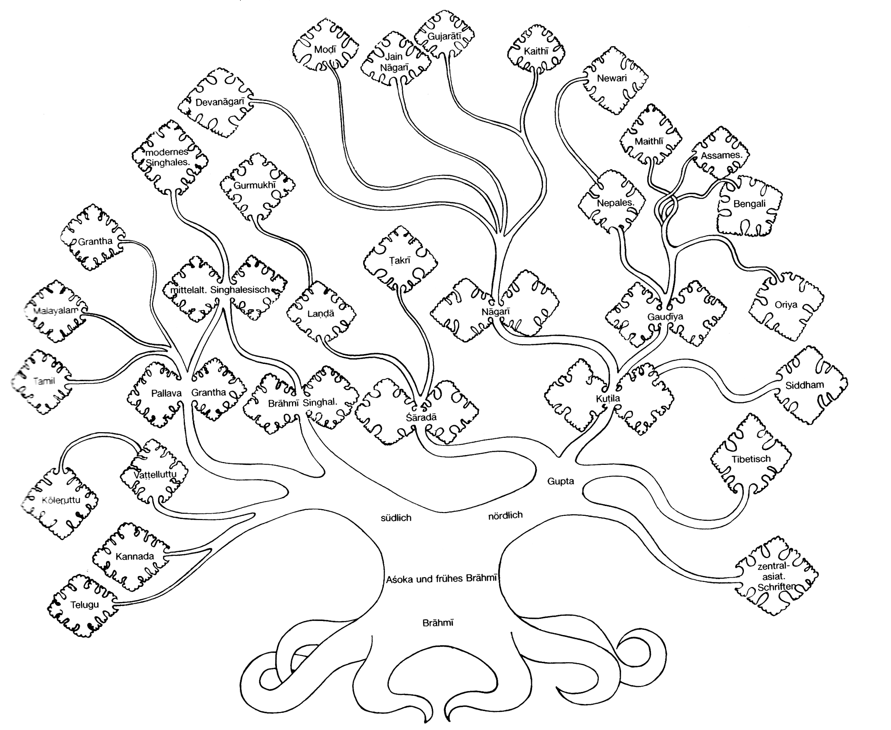

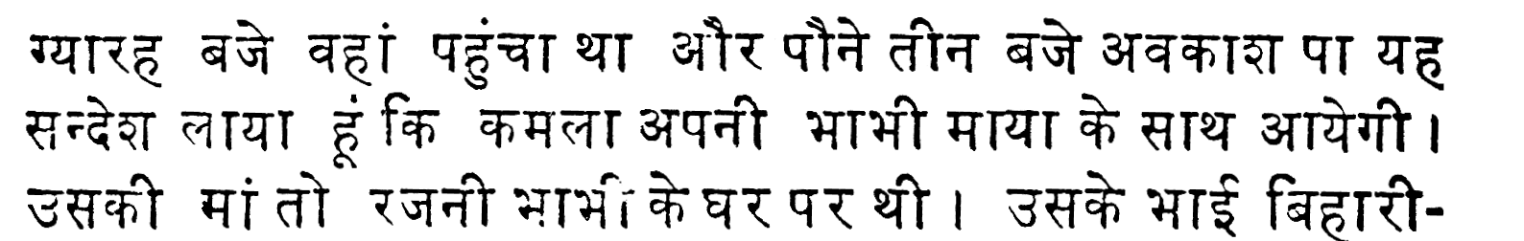
Devanagari

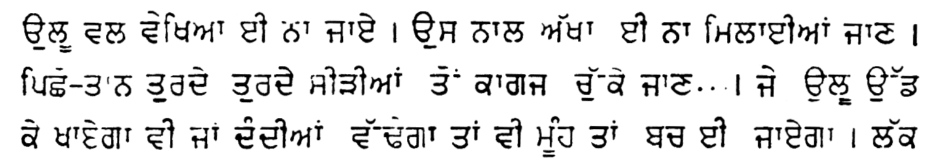
Gurmukhi

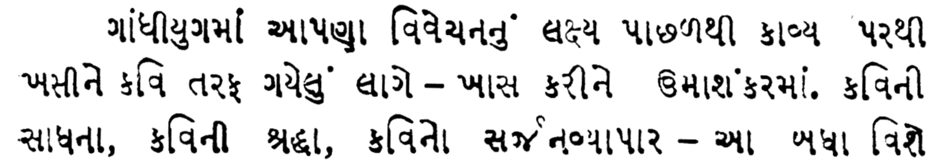
Gujarati

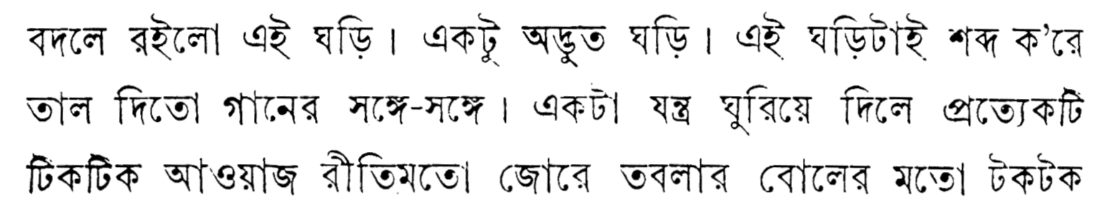
Bengali

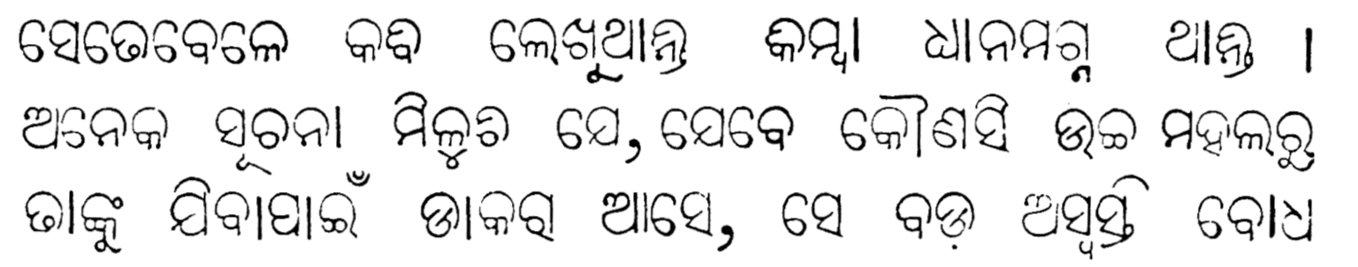
Oriya

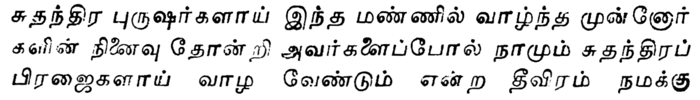
Tamil

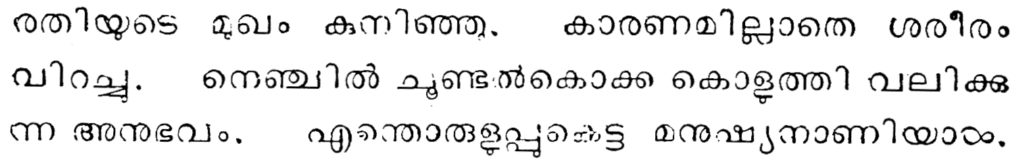
Malayalam
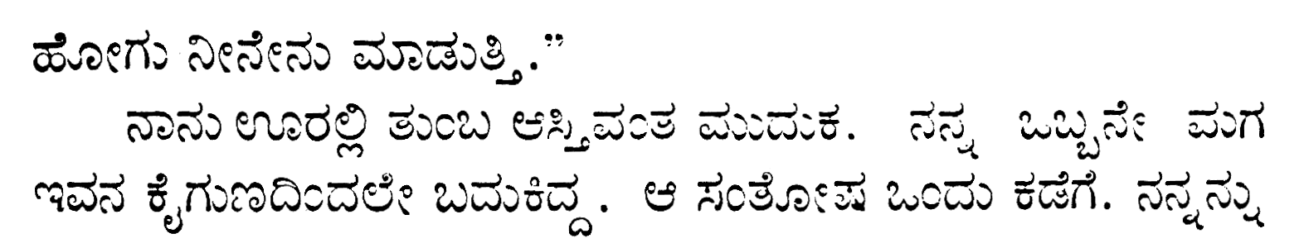

Kannada

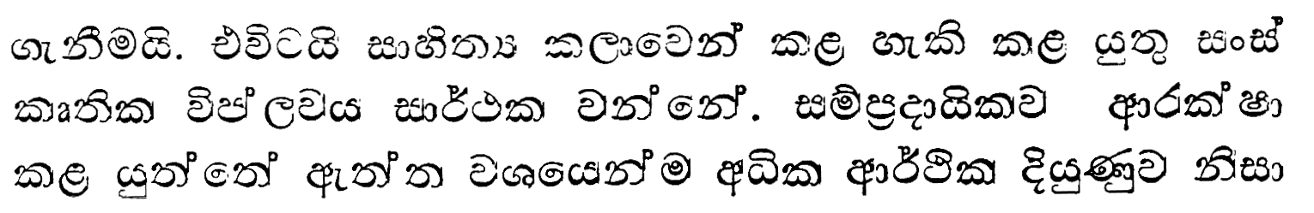
Sinhalese

No. 2 – Georgian script (Haarmann 1991: 354)

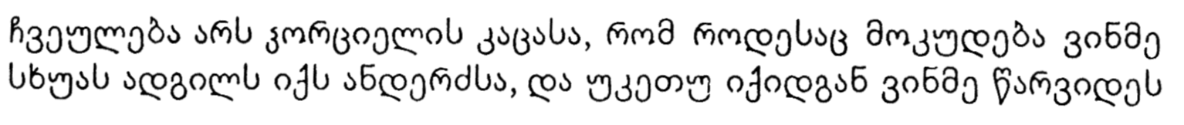

No. 3 – Old Uyghur script (Kara 1996: 541)

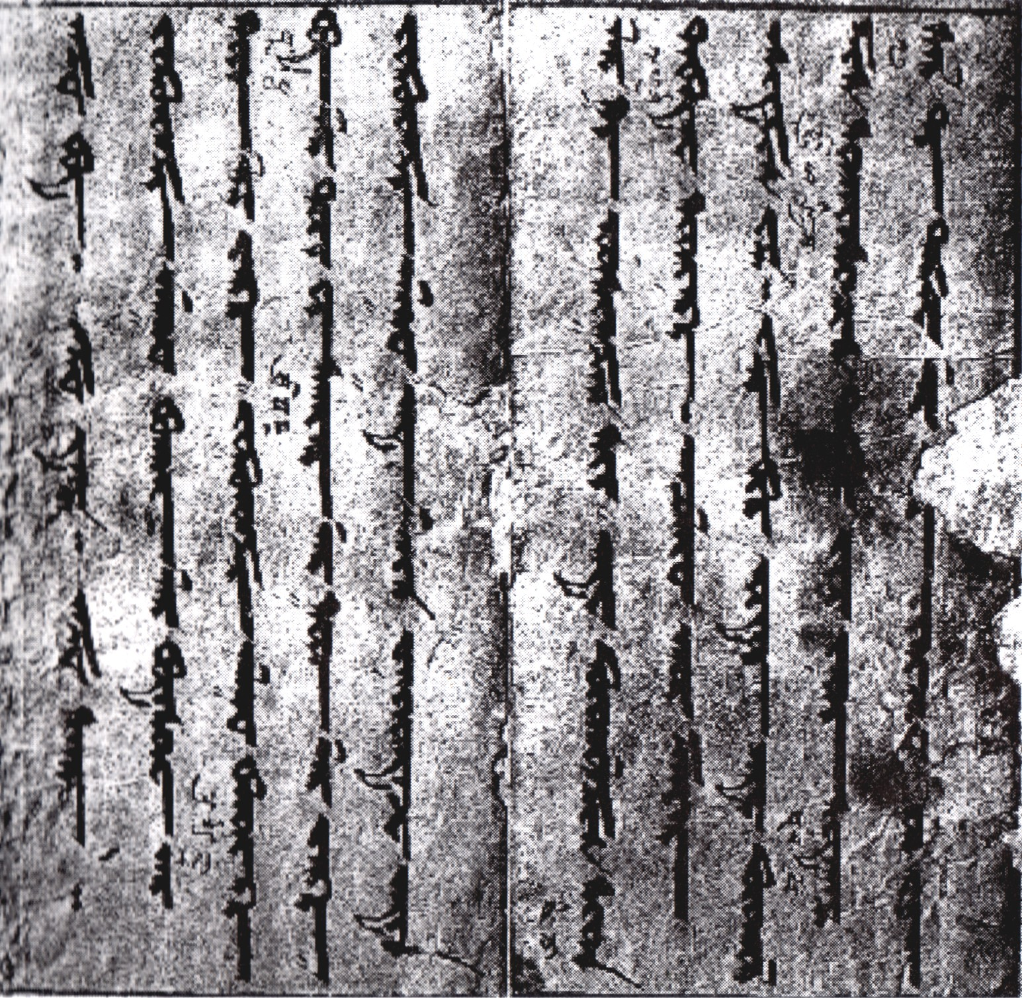

No. 4 – Cuneiform writing (Haarmann 1991: 232)
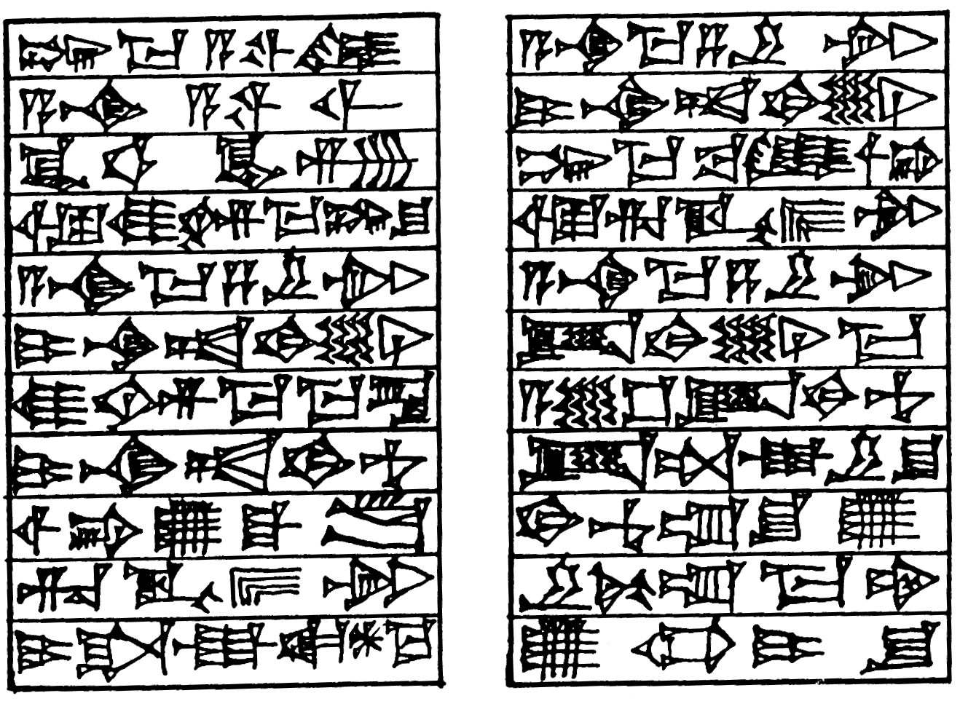

Old Babylonian

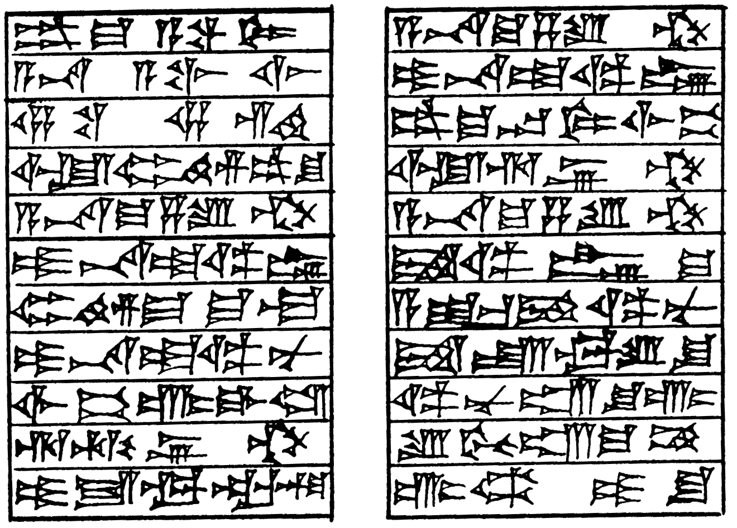

Neo-Assyrian

No. 5 – Cyrillic alphabet (Haarmann 1991: 486)

Print-Cyrillic Handwriting
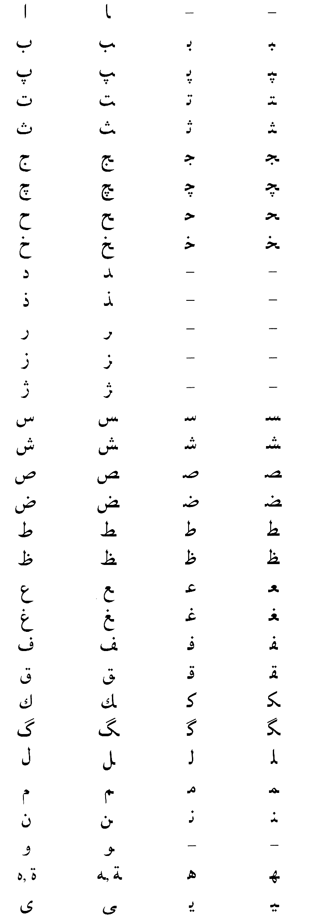
No. 6 – Arabic alphabet
(Kaye 1996: 747, 748, 754-758)
- for Farsi
- for Kurdish
- for Sindhi
- for Urdu
- for Turkish

Farsi

(from left to right:

isolated letters
final letters
initial letters
medial letters)

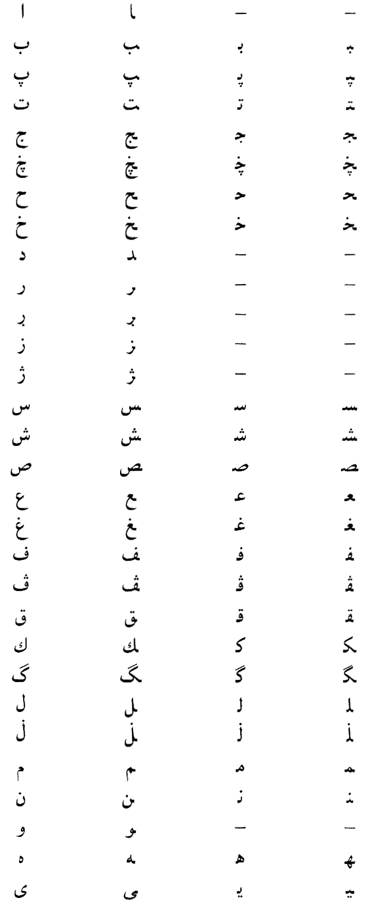

Kurdish

- consonant symbols

(from left to right:

isolated letters
final letters
initial letters
medial letters)

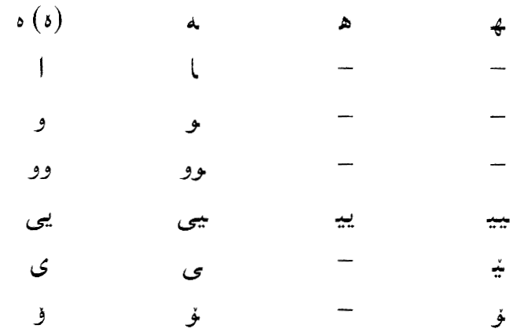

Kurdish

- vowels symbols

(from left to right:

isolated letters
final letters
initial letters
medial letters)

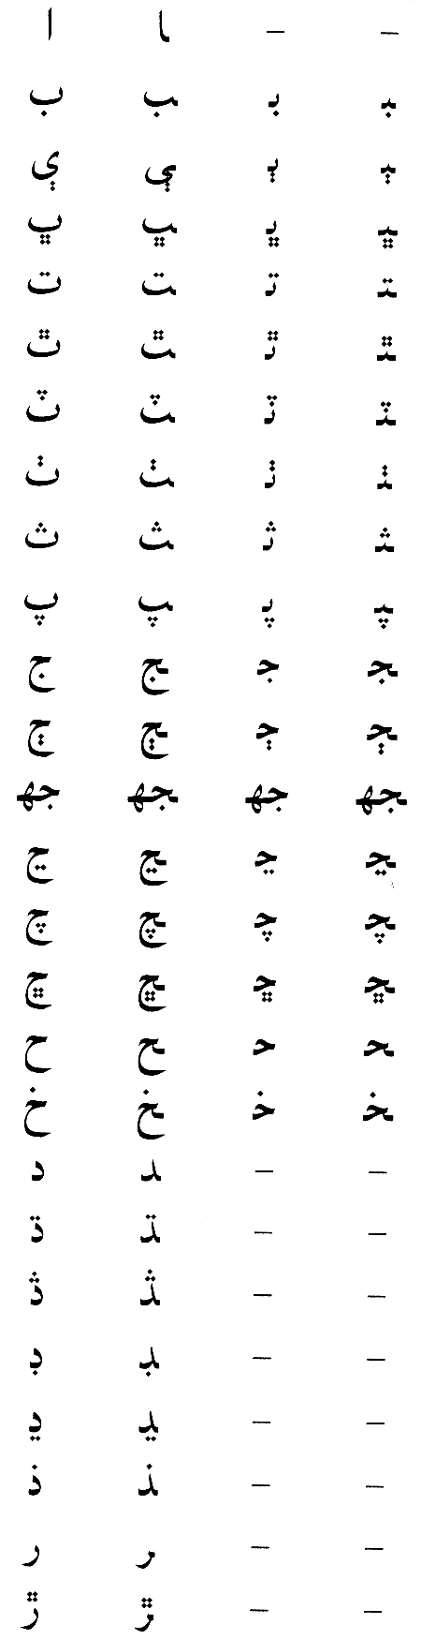

Sindhi

(from left to right:

isolated letters
final letters
initial letters
medial letters)

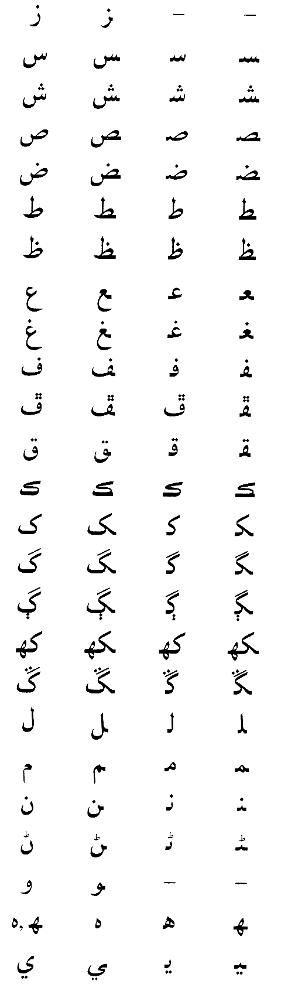

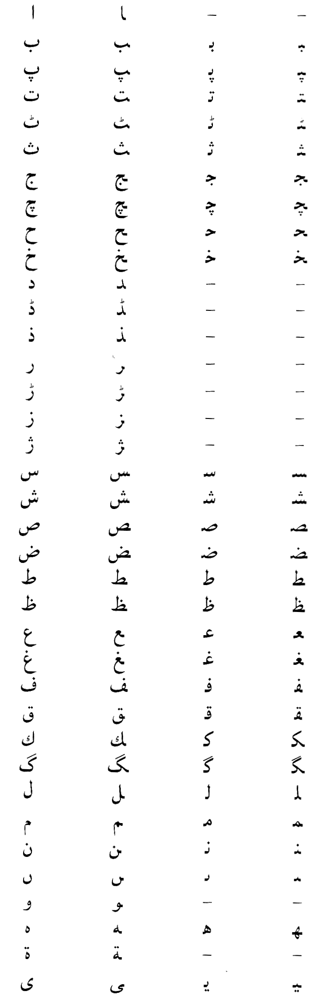

Urdu

(from left to right:

isolated letters
final letters
initial letters
medial letters)

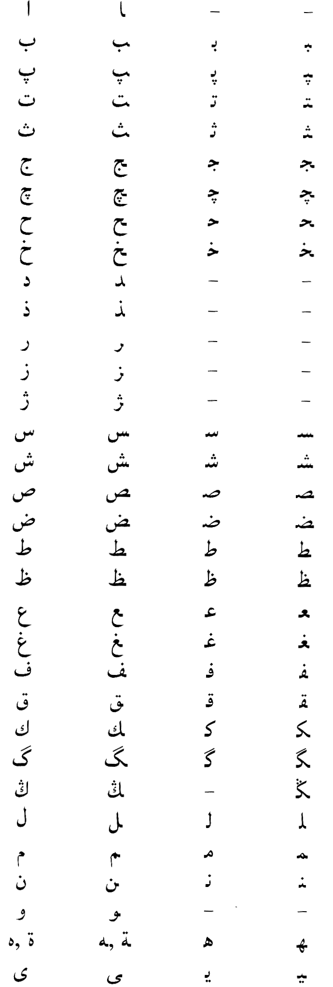

Turkish

(from left to right:

isolated letters
final letters
initial letters
medial letters)

No. 7 – Hurrian Cuneiform (Gragg 1996: 63, 64)

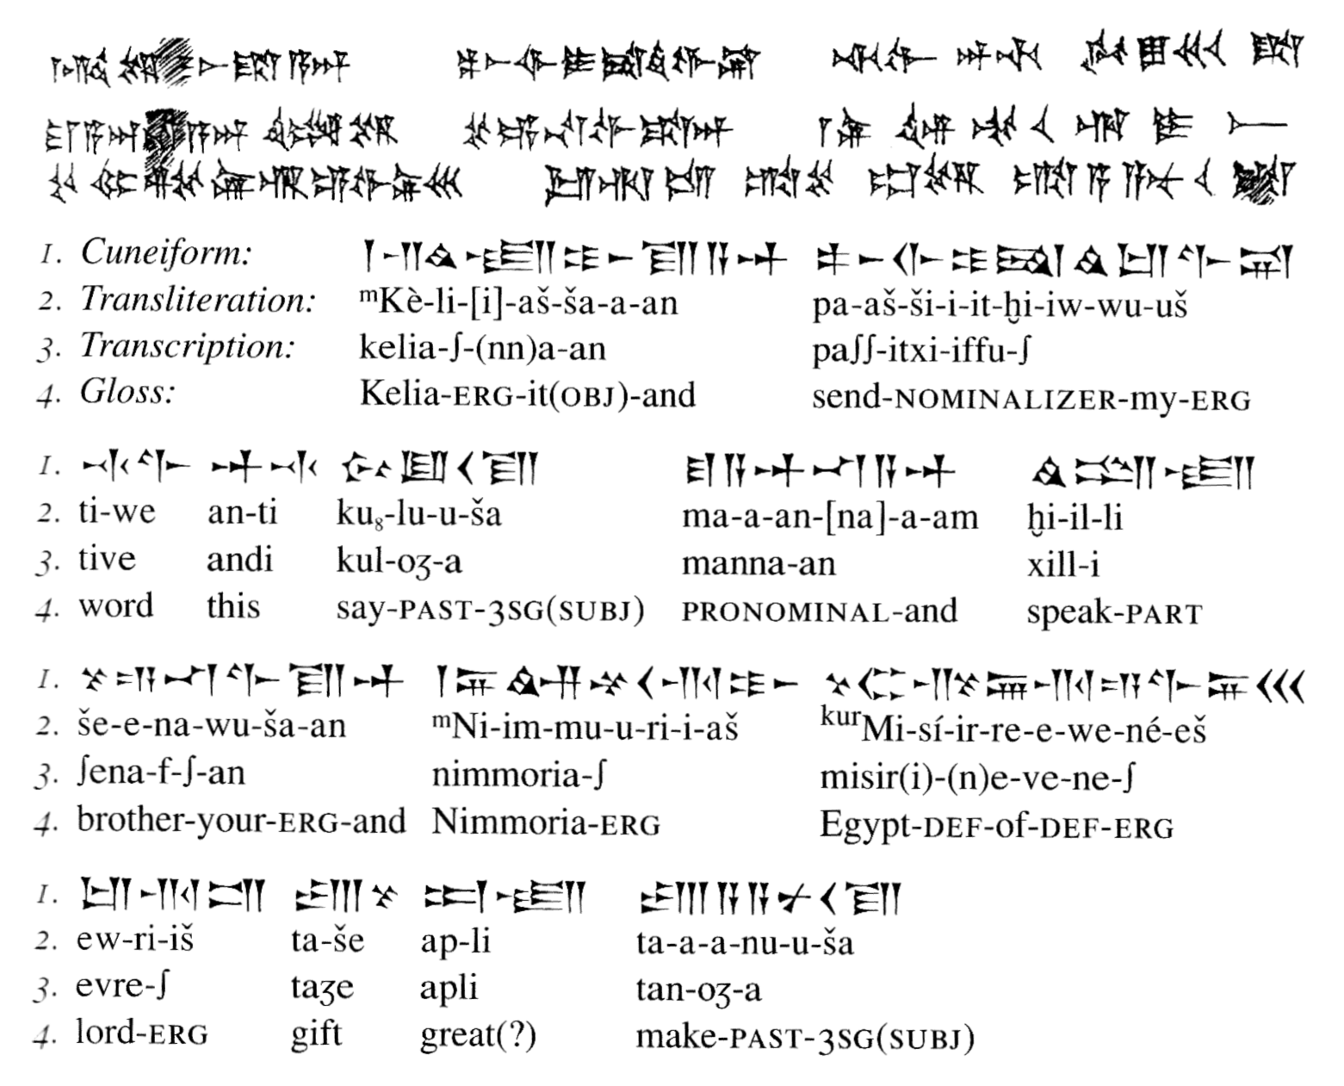
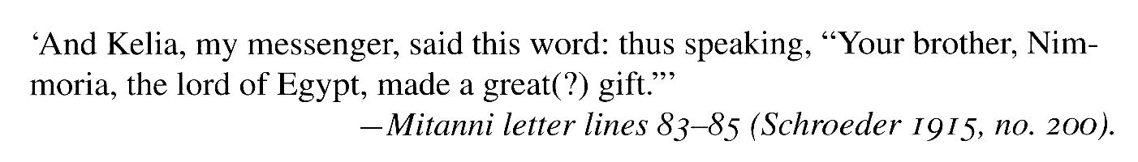
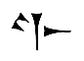

f-, v-, w-, ff-CV sign (PI)

